**Back part of car**

1. Exhaust
2. Car plate
3. Boot/Trunk
4. Brake lights
5. Indicator lights
6. Back glass panel
7. Back bumper
8. Mud guards
9. Spare Wheel
10. Spoilers
11. Back wipers
12. Reverse Sensors
13. Rear foglight

**Side of car**

1. Door
2. Side skirt
3. Wheels
4. Rims
5. Window panels
6. Door handles
7. Indicator lights
8. Side Mirror
9. Fuel cap
10. Brake discs

**Front part of car**

1. Engine hood/Bonet
2. Front grille
3. Car plate
4. Windshield
5. Lights
6. High Lights
7. Fog lights
8. Radiator
9. Front bumper
10. Sprinkler
11. Indicator lights
12. Wiper
13. Head on collision sensors

Top part of car

1. Radio antenna
2. Roof
3. Roof racks

**Interior of car (multiple views of the interior)**

From first interior view, got a view components, zoom in then we split into different parts of the interior

Components of the first interior view (before zooming in):

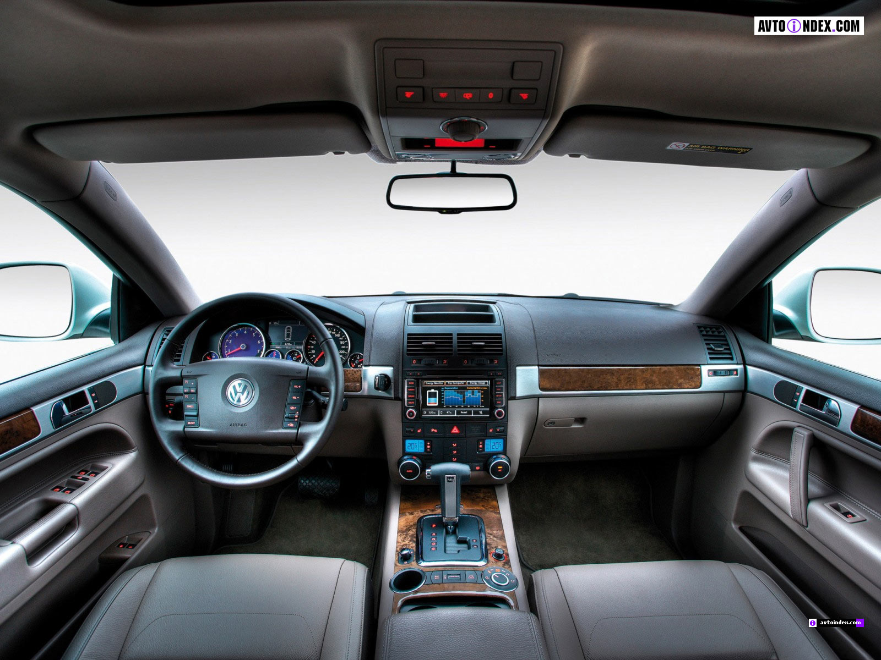

1. Steering wheel
2. Dashboard
3. Rear view mirrors
4. Sun visor
5. Gears
6. Seat
7. Glove compartment
8. Arm rest
9. Cup holder
10. Handbrake
11. Interior lights
12. Air conditioner

<http://paultan.org/2014/03/20/2014-honda-city-launch-malaysia/2014_honda_city_malaysia_010/>

or

http://paultan.org/2014/03/20/2014-honda-city-launch-malaysia/2014-city-interior/

After zooming in, first view

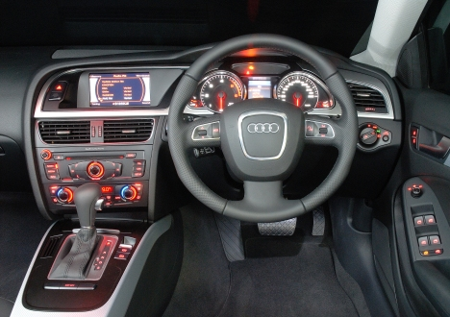

1. Steering wheel
2. Horn
3. Airbag
4. Dashboard
5. Indicator stalks
6. Light stalks
7. Wiper stalks
8. Ignition hole
9. Radio
10. Air conditioner controls
11. Cruise control
12. Hazard lights
13. Lighter

<http://paultan.org/2014/03/21/gallery-2014-honda-city-spec-spec-comparison/2014_honda_city_v_010/>

or this

<http://paultan.org/2014/03/21/gallery-2014-honda-city-spec-spec-comparison/2014_honda_city_v_011/>

After zooming in, second view,

(This picture should be taken with the driver door open (sikit cukup), taken at an angle, something like the image below, SHOULD CAPTURE ALL THE COMPONENTS LISTED)

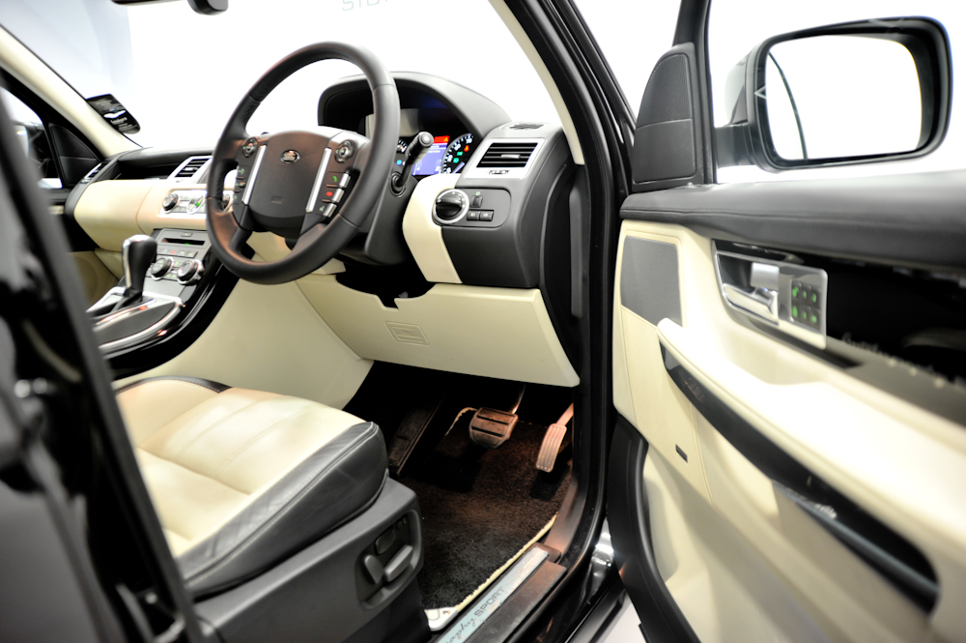

1. Accelerator
2. Brakes
3. Clutch
4. Bonet lever
5. Boot lever
6. Fuel cap lever
7. Speakers
8. Seat adjuster (put in the next one)
9. Central locking system
10. Power window controls
11. cARPETS

After zooming in, third view,

(The picture should be for a right side drive, should look something like the image below)

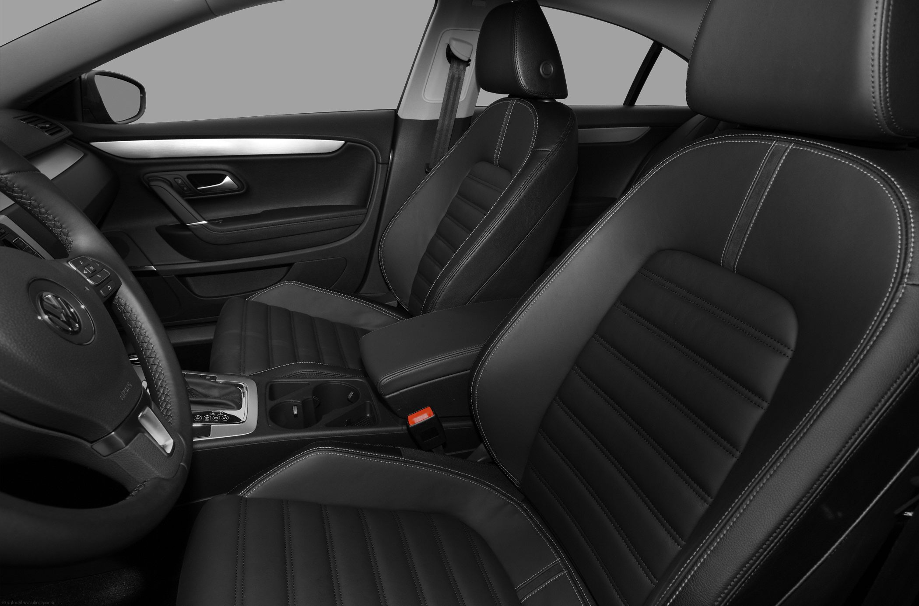

1. Seat
2. Head rest
3. Seat belt
4. Arm rest

<http://paultan.org/2014/07/07/proton-persona-executive-new-trim-level-appears-website-higher-spec-rm50k/persona-7/>

<http://paultan.org/2014/08/29/driven-audi-a3-sedan-review-malaysia/a3_sline_int_13/>

Better to use the second one as that one also has the seat adjuster on the side…

1. Steering wheel
2. Horn
3. Dashboard
4. Indicator stalks
5. Light stalks
6. Wiper stalks
7. Accelarator
8. Brake pedal
9. Clutch
10. Gears
11. Handbrake
12. Seats
13. Seat belts
14. Arm rest
15. Head Rest
16. Seat adjuster
17. Lighter
18. Cup holder
19. Rear view mirrors
20. Power window controls
21. Interior lights
22. Hazard lights
23. Air conditioner/Air conditioner controls
24. Air bag
25. Sun visor
26. Glove compartment
27. Carpet
28. Speakers
29. Central Locking system
30. Fuel cap lever
31. Ignition key hole
32. Bonet lever
33. Boot lever
34. Cruise control

Dashboard symbols   
(zoomed in)

Probably broken down into 2 parts

1. Speedometer
2. Rev meter
3. Fuel level
4. Check engine light
5. Oil check indicator
6. Handbrake indicator
7. Temperature gauge
8. Odometer
9. Trip counter
10. ABS symbol
11. Gear display
12. Indicator Symbols
13. High beam on light
14. Headlights on light
15. Foglight (front and rear) light
16. Cruise control light
17. Seat belt reminder
18. Tyre pressure fault light
19. Low battery charge light
20. Diesel glow plug light
21. 4WD Lock light
22. Door open light
23. ESC and ESC OFF light
24. Low windshield washer light
25. ECO mode light
26. Low fuel light
27. Ice warning light

